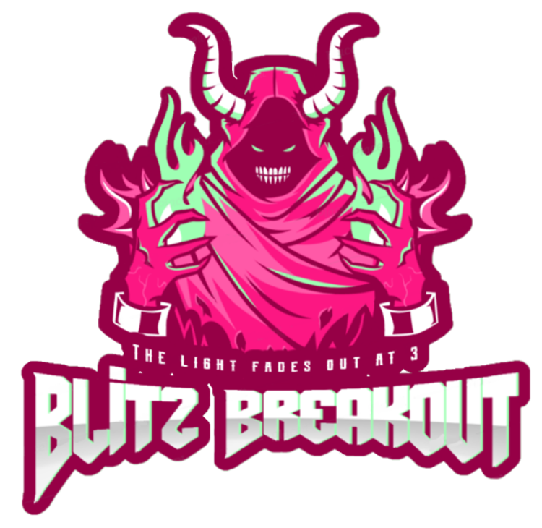

Blitz Breakout

Akash Singh, Émilie Mayodon, Sufiyan Mohammad (did 2 things)

6 November 2019

EXECUTIVE SUMMARY

The setting in the game will take place in an underground dungeon under a presumably haunted castle in Scotland, where the crypt will have brown, brick walls with moss, and the platforms will be made of grey concrete.

This game lets you jump, find clues and keys, and Easter eggs that enrich the story all while being pressured by the clock.

Many young gamers find interest in platforming games and eerie storylines; Blitz Breakout offers the two latter which targets players that come within the range of 13 to 30 years of age who represent roughly 32% of gamers[1].

OVERVIEW

In this game, the player awakens in a dark chamber, where they will be able to explore an abandoned dungeon situated in Scotland. The player can jump on a multitude of platforms to find keys, which gives access to color-coded locked rooms.  At the same time, the player can find newspaper clippings and messages that hints to a powerful presence, Zilgreth. As the player collects these items, the occult past behind the mansion is revealed progressively, and after gathering all the clues, the player realizes that the spirit, which is foreshadowed in the articles found and seen in the paintings and teddy bears, will be able to possess him at 3:00 am. At the start of the game, the player is not aware that they have limited time to escape, and as the story progresses, the time limit is brought up to realization. The time set is approximately between 2:40 am to 3:00 am with the limit being 3:00 am which is teased through clues as being the time when the demon Zilgreth regains full power and has the ability to roam through the castle and possess the player. The character provides dynamic dialogues that are attached to many actions taken by the player such as picking up newspaper clipping, or just giving hints about the current time. Every dialogue gives a better idea of his general funny and sarcastic personality.

There are multiple possibilities that can trigger four different endings: death by fall, losing all three lives, running out of time, and escaping the manor. Only one of these endings leads to victory. Running out of time, falling into pits, or colliding with enemies (spiders, bats) three times will all lead to a different game over screen depending on the way the player died. Falling will cause instant death, while bumping into enemies will take three times to kill them but running out of time is when Zilgreth will be able to possess the main character, ending the game on a bad note.

**KEY POINTS**

**Goal:**Escape the manor before 3:00.

**Genre:**Mystery / Platform game mixed with a survival aspect to it.

**Target Audience:**Mystery fans between 10 to 30 years old.

**Platform:**PC Windows, Mac.

**Major Mechanics:** Platform-based navigation, jumping, hidden clues

RELATED GAMES

***Haunted Manor 2*, iOS/Android, redBit games, 2013.**

*Haunted Manor 2: The Horror behind the Mystery* is a first-person POV horror mobile game where the player finds him/herself stuck in a creepy mansion, and must locate clues, hidden in multiple rooms, and solve complex puzzles. The appealing graphics, and chilling audio are two main points that make *Haunted Manor* one-of-a-kind, but the intricacy of the puzzles is the reason this game stands out. Despite the complexity of the riddles, which can make the gameplay relatively boring if the player is stuck, the visuals, the various settings, and the plot makes it all worthwhile as it sucks the player into the past of the Sterling family and their unfortunate mishap with the occult.

Unfortunately, it has not acquired a lot of attention as it was not published by a well-known studio; however, its lack of recognition did not interfere with the positive reviews it got, with a whopping 4.4 on 5 in the iOS App Store.

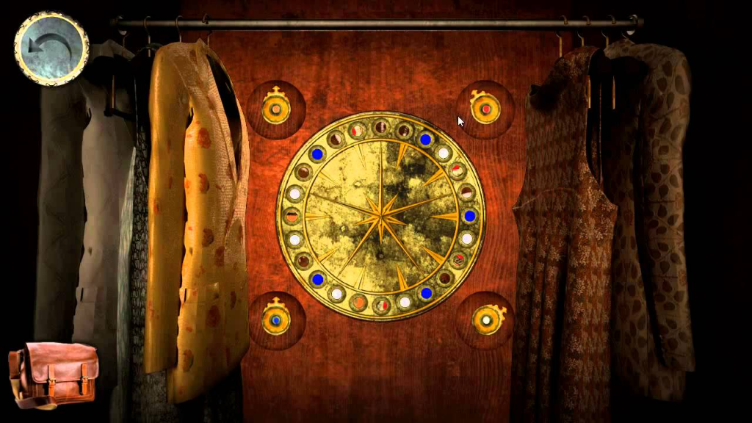

***Super Mario Bros.*, Nintendo Entertainment System, Nintendo, 1985**

The Mario Bros universe has always been the center of attention and is still today, considered one of the most successful games since the beginning of time itself. The original Mario game featured simple yet addicting jump mechanics and allowed players to fight monsters and gain power ups in an attempt to save princess Peach. *Super Mario Bros.* kept the same mechanics and expanded the lore, the changes were not drastic, but that did not have an impact on the sales. Although the plot is straightforward, the players were attracted to the simple and fun mechanics the game offered.

Another feature that the game provided were the instant death pits. Those gave players a challenge and infused them with frustration and determination; this aspect was never removed among the other Mario games that followed the same concept of 2D movement and platform-based navigation due to the sheer satisfaction players gain when completing an extra tedious level.

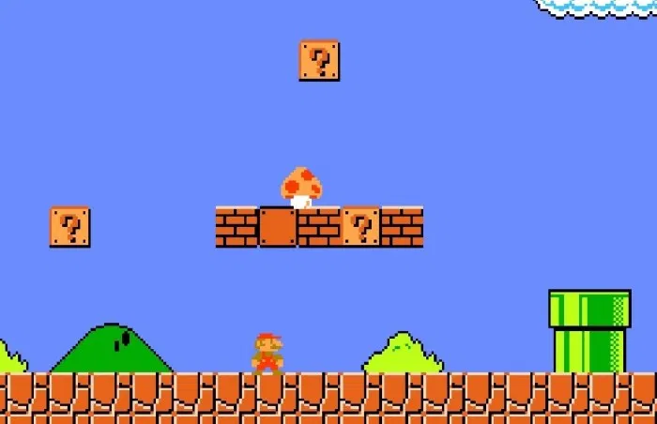

***Uncanny Valley*, PC/Mac, Cowardly Creations, 2015.**

*Uncanny Valley* delivers an unsettling aura creating suspense to bring the player on edge, which can be compared to *Blitz Breakout*’s ominous atmosphere; however, BB takes more of a supernatural twist. The game takes place in an abandoned factory where citizens live their normal lives, when the main character, Tom, senses abnormal creatures and paranoia arises within Tom and the player. *Uncanny Valley* features a story that is somewhat close to reality which pick up the interest of many. As the story progresses, the aberrant horrors riddling the rural town begins to take a more solid shape and cross the boundary to reality.

The central character is a normal security guard that follows instructions to the letter, yet after discovering the existence of those creatures, the guard embarks on a journey to find the origins of the factory and the inhuman events that took place before Tom became a guard.

As the story progresses, the player is exposed to multiple actions or routes to take, impacting the rest of the story. Effects could be a broken arm that hinders the player throughout the entire game, or the revelation of the spirits unveiling their past at the factory. Having the possibility to shape the ending to the player’s desire is a component that captivated numerous young gamers and has undoubtedly led to its success in the market.

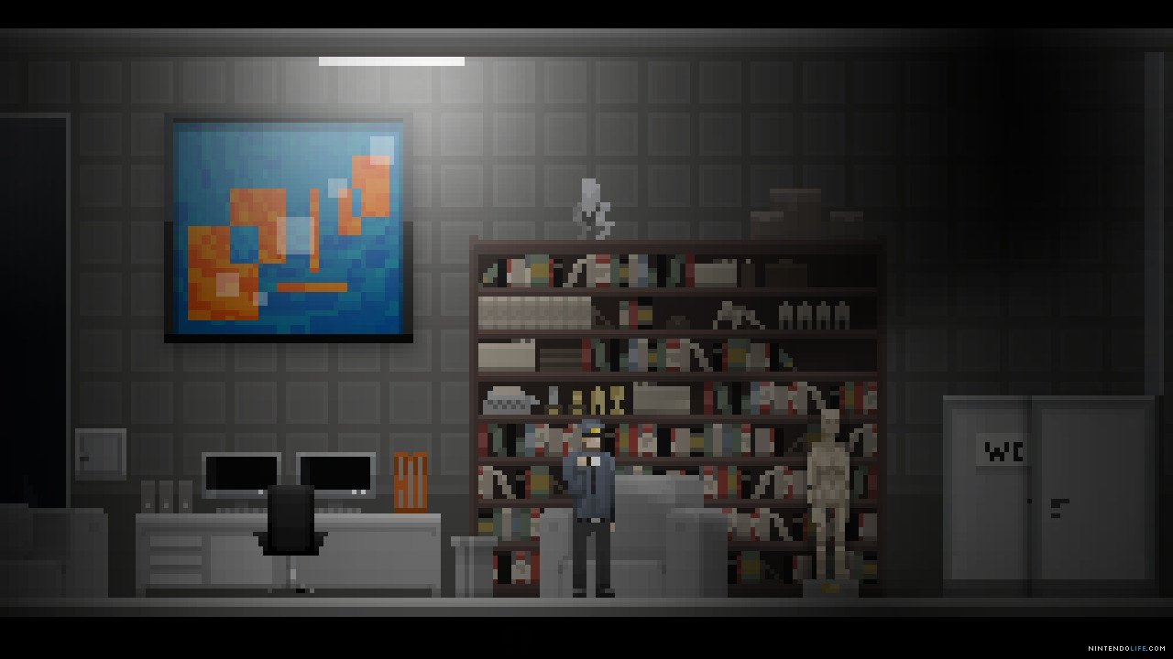

***Undertale,* PS4/Switch/PC, Toby Fox, 2015.**

*Undertale*was deemed the most successful indie game on Steam in 2016 with more than 50 thousand dollars raised on KickStarter and 500,000 copies sold after being launched only for three months. With an almost perfect score of 93% on Metacritic, and more than 90,000 positive reviews on Steam, the phenomenon that is Undertale has not ceased to charm players with its delightful characters, like Sans and Papyrus, and the humorous dialogues scattered in the game.

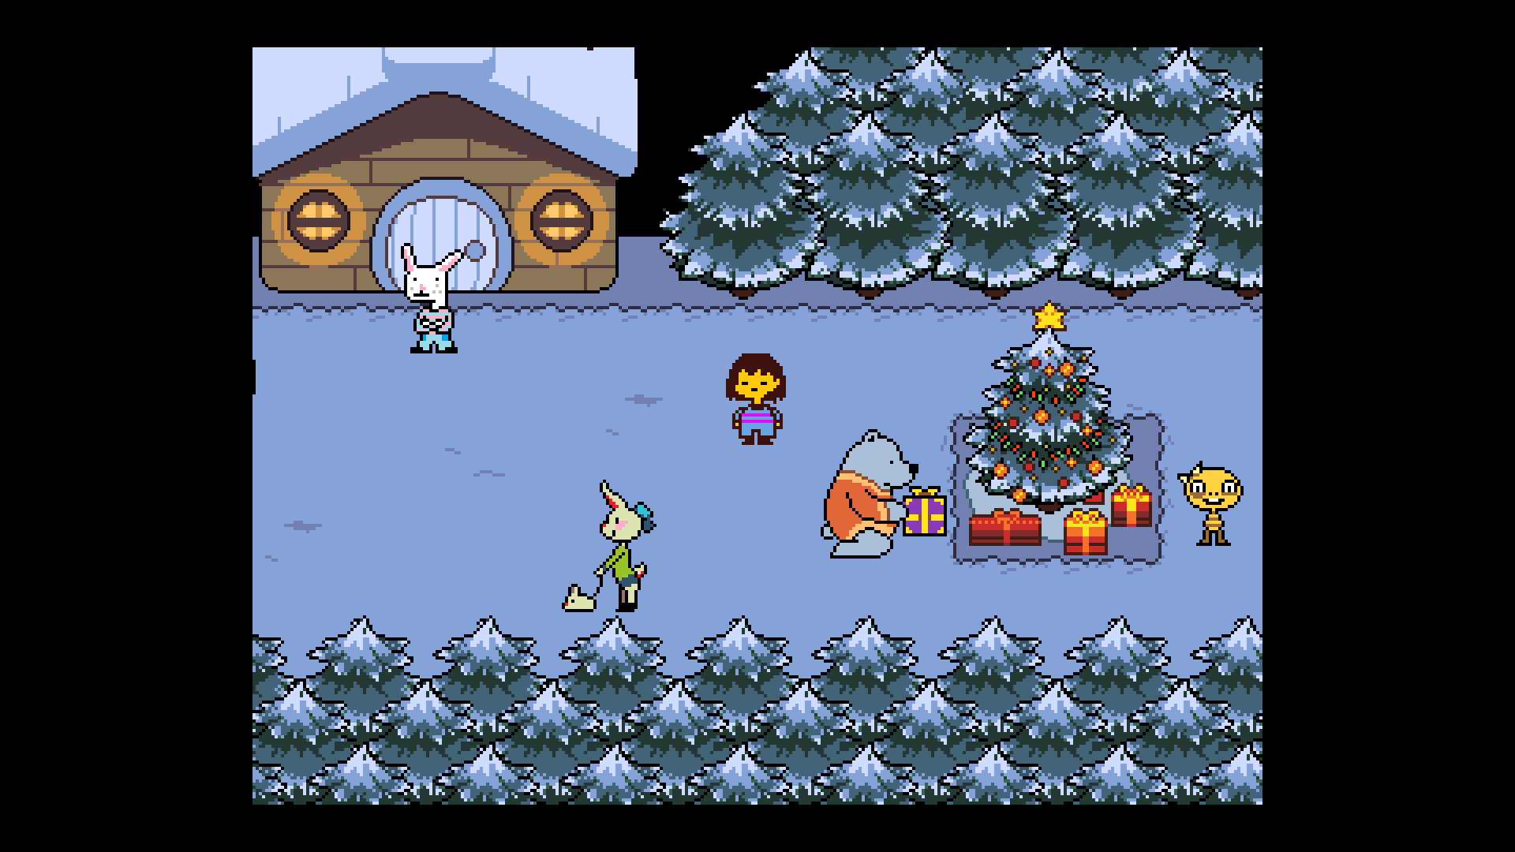Not only are the characters equipped with unique personalities and conversations, the story line diverges into three separate endings depending on the players actions and decisions: The Neutral Route (the first run), the Pacifist Route, and the Genocide Route, making the experience of the player different each time with hidden events and endings, and revealing every facet of each characters giving them full-rounded identities.

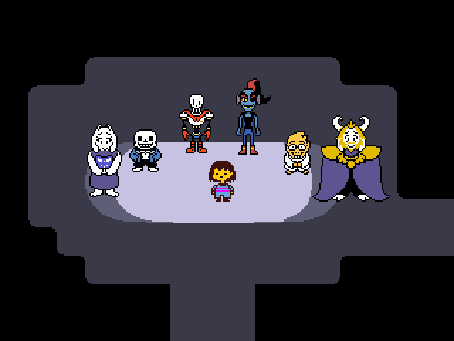*Undertale*’s old-school pixel art inspired our team to make similar character and level designs for*Blitz Breakout*as it was alluring and simpler to realize than full 3D hyper-realist visuals.

PLAYER COMPOSITES

Ayame Nishikawa, 20, student. An undergraduate at her local community college. Works a minimum wage part-time job at Stop & Shop during the weekend. Loves reading books in her free time that feature dark/mysterious plots and have links to Greek mythological deities and monsters. Watched most of the horror movies offered at the nearest Blockbuster. Favorite films are *The Conjuring* and the *Saw* franchise. Prefers living and playing video games alone every two days in her room on her Dell Inspiron 17 3000 and her iPhone 8. Prefers mobile and indie games due to them being generally cheaper. Gaming sessions varies between an hour to five depending on the day of the week and amount of homework she has. Buying her own games was a habit she developed because she wants to hide the genre she prefers, which makes it easy to avoid playing with her friends. Focuses on indie and unsettling games like *Doki Doki Literature Club*and *Detention*. Plays to satisfy her need for adventures and excitement she lacks in real life.

GAME WORLD

The game takes place in an eerie-looking manor on a stormy night. The manor keeps the Baronial Style of the Scottish Renaissance in the 16th century. Painting and torches remain after a few centuries and it was not habited since its last family during the 19th century, and the torches are still lit. The main character enters the mansion after finding the gate unlocked; however, he plunges into darkness after the ground gives way under his feet.

 When he regains consciousness, he lies in a small, underground crypt under the deserted estate. The first room contains no platforms and one unlocked door that leads to a bigger room with platforms and a mossy background. It contains multiples color-coded, locked doors, and one open. In the rooms, the player can find keys, articles about a girl, Lorraine, who went missing in the area, notes made by the last family who performed a fatal satanic ritual, and ripped pages on Zilgreth and occultism. These are hidden behind paintings, furniture, cadavers, stuffed animals, etc. where the player must find them in order to escape. The leads given are able to unlock different dialogues that pop up from interacting with various objects in the décor.

There is no source of light except for the torches illuminating the walls giving the rooms a medium glow. The final room is going to have a set of stairs leading to the exit where the moon shines through and provides more light than other rooms creating a more calming atmosphere.

GAME CHARACTERS

**Flynn:**

Flynn has always loved to wander aroundin new cities in search of thrilling adventures. Upon losing everyone he ever cared for in Australia and everyone else he fell in love with, he embarked in a journey to explore the world with the intention of moving as far away from home. With a fit body, an enthusiastic mindset, a foreign language degree, and a deceased lavish father, he took on board a flight to Scotland, leaving beautiful Bangkok behind, and is currently residing in Cruden Bay. Drinking and travelling are the only things that amuses him in life. Unemployed and not up-to-date with fashion, he wears what he thinks looks best and starts the day by turning on the engine of his Dodge Challenger 1970 in anticipation for a new experience.

**Zilgreth:**

An ancient entity first appearing in scriptures of the Old Testament between 1200 and 165 BC where it was depicted as Satan’s vicious disciple. It was seen as a demon who deceived its victims into offering their souls after completing their dirty biddings. Its name later emerged in archives and writings dating back to the 17th century when the Salem Witch Trials transpired. It was recorded that it bewitched young girls and women into performing perverse acts leading to their deaths. It was no longer seen in books until the 19th century where a cult failed into containing Zilgreth during an attempted ritual resulting in the mysterious disappearance of the members in their private dwelling.

PROGRESSION GRAPH

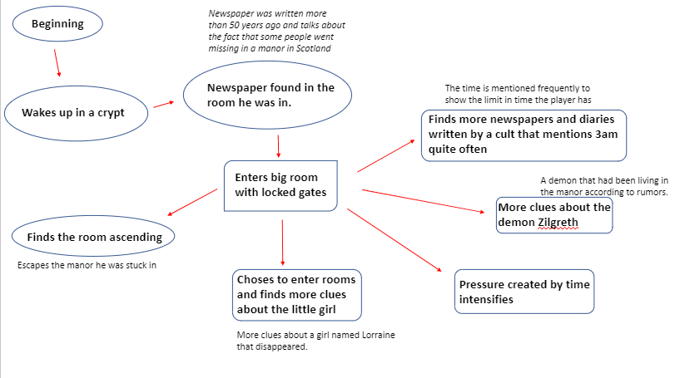

ART DIRECTION

The style of the game was originally 3D, but the team later decided to go for a pixelated look to keep things simple while not hindering the potential of conveying a rich and mysterious story. The idea behind Flynn was making him a person that is overly enthusiastic and would not care about the situation he is in while always pitching funny and sarcastic comments on the tiniest things. Characters from *Dan the Man*and *Super Mario Bros.* inspired Flynn’s design. A smile and a pair of simple jeans were integrated to further make him look like any other, but his hairstyle gives him a unique flair.





USER INTERFACE STORYBOARDS

HUD and GUI play a major role in our game. When it comes to the HUD, lives and time are the two main elements that the players will notice. The top left side of the screen will feature three bit red hearts that indicates the number of lives remaining. The bottom left section is reserved for an inventory that holds all the items the player collects. The objects are used to unlock dialogues and doors. The inventory also lets the players revisit documents, diaries, newspaper clippings, and other items to have a better general understanding of the situation they are in. Items will be scattered across the rooms and some are hidden and can only be found by removing or by activating certain dialogues by simply entering new rooms or pressing the interact button. Keys are also one of the objects that are found in the manor, some of these are color-coded and some are not, matching the gate’s colors. The top right-hand side of the screen features a clock that represents Flynn’s watch. It is displayed as a digital clock that has its numbers painted in white and shows the hour, minutes and the seconds marching forward.

TAGS AND DIALOGUES

Dialogues reflect on the current situation of the player. If Flynn is looking at an item, remarks come in the shape of dialogues to give hints to the player, emphasizing key points of the story line that might have been overlooked like “This is one *hella*creepy*lookin’*dude” or “I’ve seen this dude before in the other diary” with a tag: RECALL. Other dialogues are displayed when the player reaches a set location or if the time is about to run out. If the character reaches the edge of the first pit shown in the game, a series of dialogues such as “WOAHHHHH THAT’S A HOLE, THAT’S A DEEP HOLE” and “I should avoid jumping in it!” are displayed with a tag: REACT. There are also some dialogues focusing on the HUD with the player’s interactions with the environment aspect of the game which includes the current remaining lives, the existence of enemies, and the number of items in the inventory such as “I don’t think I’ll last long if these spiders keep touching me”, “STAY AWAY YOU HAIRY 8 LEGGED BUGS”, “I WANT TO SQUASH YOU SOOO BADDDD”, “These spiders sure as hell sting hard!”, “I think I could fit more papers in my pockets” all regrouped in the tag: INTERACT.

TECHNOLOGY PLAN

The software and sites used to fully produce Blitz Breakout are:

-Greenfoot

-Microsoft Word

-Paint/Paint3D

-GIPHY

-Snip and Sketch

-Muse Score

-FL Studio

To produce the Game Design Document, our team used Microsoft Word Online to work on the document together, and we later put it on Microsoft Word to make it official and cleaner. We also used Google Images to acquire some of the visual files used.

The artist used Paint3D, Paint, and Snip and Sketch to draw the first version of the main character. He then used GIPHY to animate it and make him jump and walk. He also made the demo of one of our rooms in Paint3D where he took a mossy brick picture and created a whole wall with it. He later on added platforms and doors to it.

Blitz Breakout was created on Greenfoot only, an IDE that uses Java or Stride as programming languages. It is usually employed for making two-dimensional simulation or interactive games.

The musician used Muse Score at first to create a few original tracks, but then later used FL Studio to make it in 8-bit. He also wrote different tracks for when the player either loses or wins the game, and for the menu of the game.

The hardware used are:

-3500$ worth of computers (private and school property)

-Regular desks

We used our own computers every night to work on the Game Design Document on our regular workstations.

SOFTWARE ARCHITECTURE

**Middleware:** Greenfoot is a software used predominantly by students as a portal to gain knowledge and start building the simple two-dimensional graphic applications. Yet, it is still open to art formed in different software such as Paint3D. Every physics and interactions the game featured is integrated by Greenfoot, using a high-level programming language, Java, and packages such as Sublime Text 3.

**Physics Engine:** Real life physics such as gravity and the size of the character model heavily inspired the creation of numbers that were inserted inside the Greenfoot software that turned them into vectors through Java and forged the maximum height and speed at which the character would fall in Blitz Breakout.

**Art Pipeline:** Concept: The game had to feature a character that would easily reflects his personality by altering his form of speech (dialogues intended to be a part of the game). Every single object and dialogues would be formed to make the game focus more on a specific story line and engaging gameplay mechanics instead of an environment-art oriented game.

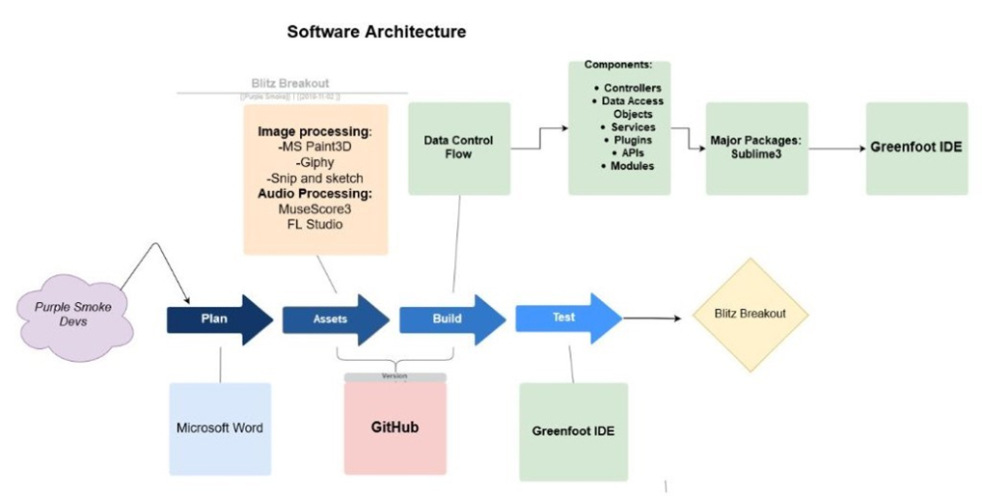

CONTROLS

Move to the left

Move to the right

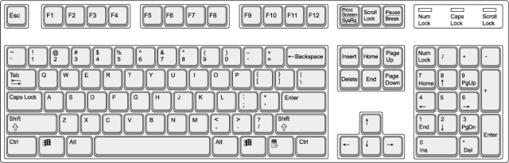

Interact with items



Jump

Open/Click inventory

LEVEL DESIGN

As the game progresses and the player enters and unlocks more doors, the game becomes progressively harder with the introduction of enemies: spiders. The first few levels would feature basic jumping action, starting from an elevated position and pushing the player into reaching another position, which is at a lower altitude to give them a better understanding of the velocity and gravity the game features. After a few levels, the elevation begins to shift, the player now has to reach objectives or collect items that are located at a higher position than the one they start at. This enhances the players knowledge about the strength velocity and gravity the game follows. With that, the platforms will begin moving either diagonally or horizontally and will soon feature spiders which will begin showing the difficulty of the game. As the game progresses, the platforms adopt a much less repetitive movement style and the enemies grow larger in numbers. Some platforms seem non-existent and hold secret items that may be picked up by the user if they dare, otherwise, the flow of the game does not depend on discovering what those items hold.

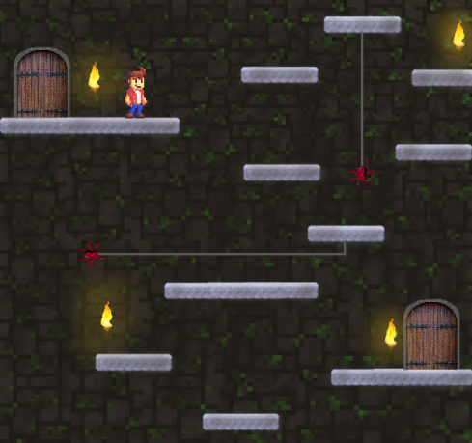

MECHANICS ANALYSIS

There are quite a few mechanics in this game. The core mechanic of this title is platformer. Platformer is a classic game mechanic; it’s been around video games for a long time and is a reliable option to make a fun game. The idea of platforming can seem quite simple, but it can prove to be a challenge at times which make the game alluring.

Platforming requires some skill factor and reflex on behalf of the player. For instance, moving platforms, the player must anticipate the right moment to hop on the platform. Platforming can be influenced by a lot of other key components to make it more fun. For example, in Blitz Breakout the mechanic of time flowing and getting closer to the deadline puts pressure on the player to complete the game and reach the finish line as soon as possible. This can lead to the player trying to rush the game and make mistakes. The player may anticipate the jump prematurely and miss the landing, the player now lost a valuable amount of time and a life as they must repeat the level without making the same blunder.

 A game that use similar mechanic to it is Super Mario Bros. The classic NES platformer that featured a time mechanic. Not many people notice, but on the top right of the screen there is a time indicator. Once the timer hits 100, the music speeds up and the players usually notice the timer and try to complete the level as fast as possible. If the timer hits zero, Mario dies and must restart the level. The purpose of the time mechanic is to make sure the player does not find the game dull. The time mechanic keeps the player in constant motion. An alternative mechanic could have been lava rising from the floor, but that doesn’t correlate with the lore of the game.

SCHEDULE

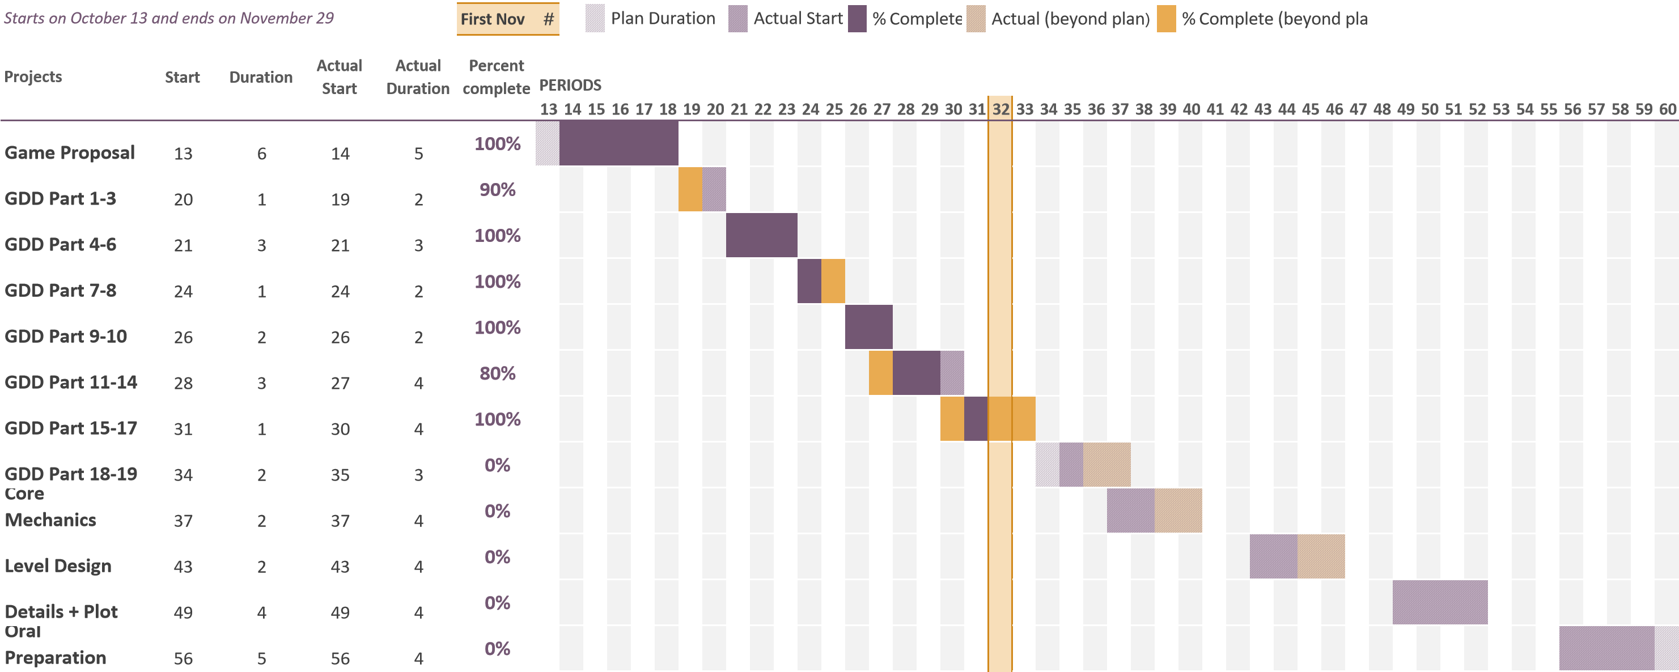

**Staffing Plan:** Mechanic analysis’ and software architecture writers are the most in demand right now. None of our team members are engineers and we need to hire someone who can write a Technical Design Document for the making of this game.

**Key Developers:** Leaders will need to be good at directing members and motivate them into working more efficiently. Producers will need to be able to create quality content and be qualified to work in teams. Managers will need to be time-efficient and make sure that every deadline is met within budget and on time.

**Status:** The Game Proposal is finished, and the Game Design Document is nearly completed. The physical game is not being worked on right now, but we are planning to start implementing core mechanics and level design as soon as we finish the GDD.

1. https://www.statista.com/statistics/722259/world-gamers-by-age-and-gender/